Phase-3 Design & Solution Architecture (Phase Project)
Field | Details
Date | 28-09-2026
Team ID | SWTID-2026-8733
Project Name | Implement Client Script & UI Policy (Incident)
Maximum Marks | 4 Mark

Design & Solution Architecture
The Phase Project stage translates functional requirements into concrete platform configuration and technical script designs on the ServiceNow platform. This phase details the architectural framework, component interactions, field logic rules, and client-side execution steps required for the incident table
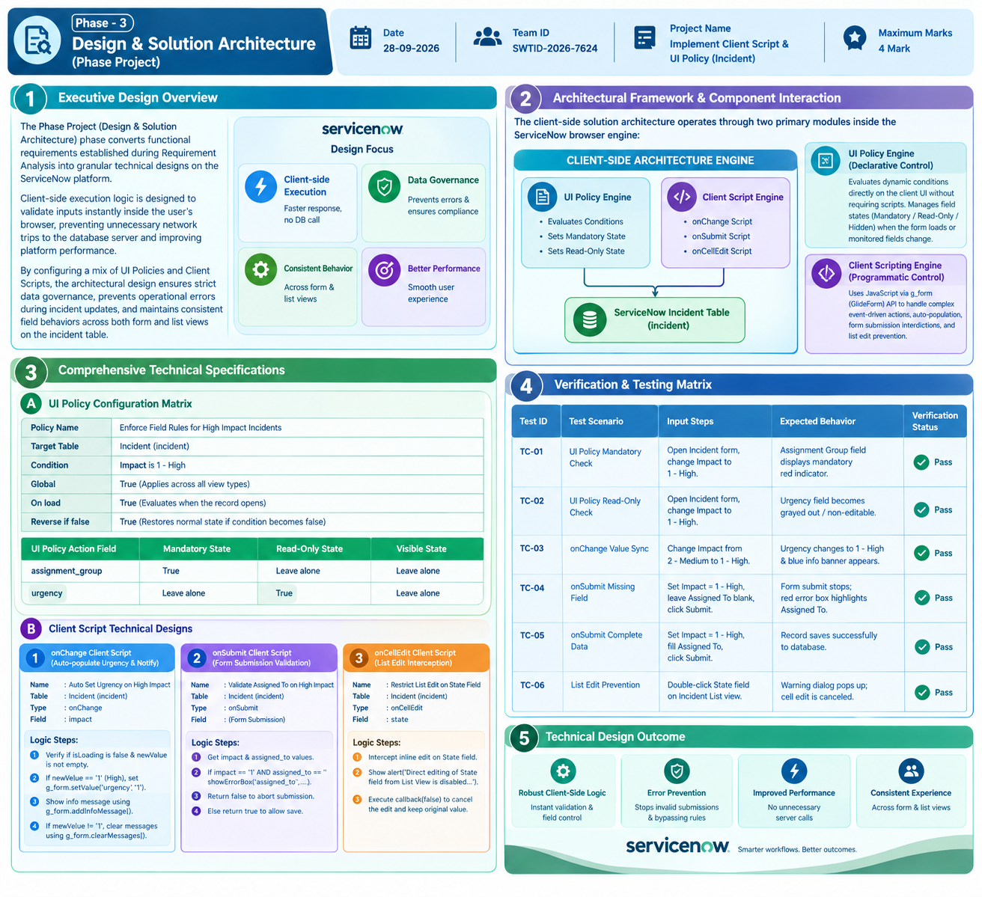1. Executive Design Overview
The Phase Project (Design & Solution Architecture) phase converts functional requirements established during Requirement Analysis into granular technical designs on the ServiceNow platform. Client-side execution logic is designed to validate inputs instantly inside the user's browser, preventing unnecessary network trips to the database server and improving platform performance.
By configuring a mix of UI Policies and Client Scripts, the architectural design ensures strict data governance, prevents operational errors during incident updates, and maintains consistent field behaviors across both form and list views on the incident table.
2. Architectural Framework & Component Interaction
The client-side solution architecture operates through two primary modules inside the ServiceNow browser engine:
+-----------------------------------------------------------------------------------+
| CLIENT-SIDE ARCHITECTURE ENGINE |
| |
| +--------------------------+ +----------------------------+ |
| | UI Policy Engine | | Client Script Engine | |
| | | | | |
| | - Evaluates Conditions | | - onChange Script | |
| | - Sets Mandatory State | | - onSubmit Script | |
| | - Sets Read-Only State | | - onCellEdit Script | |
| +------------+-------------+ +-------------+--------------+ |
| | | |
+----------------|-----------------------------------------------+------------------+
| |
+-----------------------+-----------------------+
|
▼
[ ServiceNow Incident Table (incident) ]
- UI Policy Engine (Declarative Control): Evaluates dynamic conditions directly on the client UI without requiring scripts. It actively manages field states (Mandatory / Read-Only / Hidden) whenever the form loads or monitored fields change.
- Client Scripting Engine (Programmatic Control): Uses JavaScript via the g_form (GlideForm) API to handle complex event-driven actions, auto-population, form submission interdictions, and list edit prevention.
3. Comprehensive Technical Specifications
A. UI Policy Configuration Matrix
- Policy Name: Enforce Field Rules for High Impact Incidents
- Target Table: Incident (incident)
- Condition: Impact is 1 - High
- Global: True (Applies across all view types)
- On load: True (Evaluates when the record opens)
Reverse if false: True (Automatically restores normal state if condition becomes
UI Policy Action Field | Mandatory State | Read-Only State | Visible State

assignment_group | True  PDF | Leave alone | Leave alone
urgency | Leave alone | True | Leave alone

B. Client Script Technical Designs
1. onChange Client Script (Auto-populate Urgency & Notify)
- Name: Auto Set Urgency on High Impact
- Table: Incident (incident)
- Type: onChange
- Field Name: impact
- Logic Execution Steps:
  - Verify if isLoading is false and newValue is not empty.
  - If newValue == '1' (High Impact), invoke g_form.setValue('urgency', '1') to auto-populate Urgency to High.
  - Trigger g_form.addInfoMessage('Urgency has been automatically updated to High due to High Impact choice.').
  - If newValue != '1', clear former informational banners using g_form.clearMessages().
2. onSubmit Client Script (Form Submission Validation)
- Name: Validate Assigned To on High Impact Submit
- Table: Incident (incident)
- Type: onSubmit
- Logic Execution Steps:
  - Retrieve impact value using g_form.getValue('impact').
  - Retrieve assigned_to value using g_form.getValue('assigned_to').
  - Evaluate condition: If impact == '1' AND assigned_to == '' (empty):
    - Execute g_form.showErrorBox('assigned_to', 'Assigned To user is required before submitting a High Impact incident.').
    - Return false to abort the save/submit process.
  - If condition fails, return true to allow the form to save successfully.
3. onCellEdit Client Script (List Edit Interception)
- Name: Restrict List Edit on State Field
- Table: Incident (incident)
- Type: onCellEdit
- Field Name: state
- Logic Execution Steps:
  - Intercept user inline edit attempt on the State field from the list view.
  - Prompt alert modal: alert('Direct editing of State field from List View is disabled. Please open the Incident form to update State.').
Test ID | Test Scenario | Input Steps | Expected Behavior | Verification Status
TC-01 | UI Policy Mandatory Check | Open Incident form, change Impact to 1 - High. | Assignment Group field displays mandatory red indicator | Pass
TC-02 | UI Policy Read-Only Check | Open Incident form, change Impact to 1 - High. | Urgency field becomes grayed out / non-editable. | Pass
TC-03 | onChange Value Sync | Change Impact from 2 - Medium to 1 - High.  PDF | Change Impact from 2 - Medium to 1 - High.  PDF | Pass
TC-04 | onSubmit Missing Field | Set Impact = 1 - High, leave Assigned To blank, click Submit | Form submit stops; red error box highlights Assigned To. | Pass
TC-05 | onSubmit Complete Data | Set Impact = 1 - High, fill Assigned | Record saves successfully to database.  PDF | Pass
  - Execute callback(false) to discard changes and maintain original list value.
  - Verification & Testing Matrix

